Conversions: C47/R47 Structural and FEA conversions

Introduction
Structural engineers routinely move between SI and imperial data, and between the intuitive engineering units of a property table and the non-intuitive consistent units an FEA solver demands. The R47/C47 now provides a menu hierarchy under CONV that covers these conversions across sections, materials, loads and mass.
This document describes the Struct: sub-menu, the display modes best suited to structural work, and the number entry and conversion conventions. Two worked examples follow: converting imperial section and material properties to metric equivalents, and preparing consistent-unit inputs for an FEA model.

Table of Contents
Conversions: C47/R47 Structural and FEA conversions 1
Introduction 1
Table of Contents 1
Structural engineering parameters 2
Number display modes 3
Struct: sub-menu details 3
General menu structure 4
Number entry examples 4
Conversion direction arrows 5
Conversion result unit display 5
Conversion examples 5

Structural engineering parameters
Structural engineering involves calculating strengths of materials and structures. Design of structures often involves following international standards with local code variations relevant to the region. For example, regions subject to snow require compliance with additional snow loads and tropical areas require compliance with high wind loads. Depending on the region, calculations and methods are generally based on SI units or Imperial units. These standard units are often modified with prefixes to generate whole numbers that are easy to display and tabulate.
Tables of material properties are generally available from suppliers, as well as standard industry resources. Depending on the source of the materials, data is often only published in Metric units or Imperial units.
When working with FEA (Finite Element Analysis) systems, the software enforces that a consistent system of units is used. This will often require the conversion of properties to alternative units that are non-intuitive. For example, creating an FEA model in mm, using N for force and kg for mass will require that material density in units of tonnes/mm^3. Imperial units are even less intuitive.
The C47/R47 now provides a Menu hierarchy of conversion functions that cover the structural engineering domain. This menu system is easy to use and navigate.

The menu system is accessed via:
R47: [f, 2] (CONV) C47: [f, 5] (CONV)
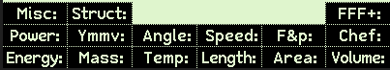
[g, F2] (Struct:)
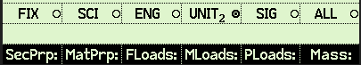
Number display modes
Elements of Struct: menu

Number display modes
Display mode | Description | Example  12345.6789 | Display example
FIX | Fixed point decimal display | FIX-2 (2 decimal places) | 12345.68
SCI | Scientific display mode. Exponential display. | SCI-3 (3 decimal places) | 1.235×⑽⁴
ENG | Engineering display mode. Exponent is a multiple of 3 | ENG-3 | 12.35×⑽³
UNIT | Exponent displayed as SI suffix (eg. m, k, M) | UNIT-3 | 12.35 k
SIG | Significant digits | SIG-3 | 12350.
ALL | All decimal places | ALL-3 | 12345.6789

FIX and UNIT display modes can be most useful with structural conversions.
To make use of the UNIT display mode, number input should be set to Real.
To set Real input mode:
R47: [f , 1] (PREF Menu) [↑, f, F2] (iℝ) C47: [f , CHS] (MODE Menu) [↑, f, F2] (iℝ)

Struct: sub-menu details
Menu | Description | Details
SecPrp: | Section property conversions | 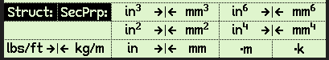
Typical section properties given in property tables for steel and ALU sections.
Includes: mass/unit length- (kg/m, lbf/ft), area ($mm^{2}, in^{2}$), Section modulus- ($mm^{3}, in^{3}$), 2nd moment of area- ($mm^{4},in^{4}),$ Warping constant- ($mm^{6}, in^{6}$)
MatPrp: | Material property conversions | 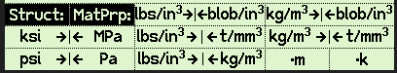
Typical material properties.
Includes modulus of elasticity, Yield strength, Ultimate strength (Pa, psi), Density (kg/$m^{3}$, t/$mm^{3}$, lbs/$in^{3}$, blobs/$in^{3}$ )
FLoads: | Force-based load conversions | 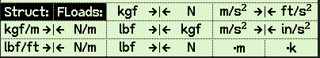
Typical force-based loads.
Includes force/length (N/m, kg/m, lbs/ft), force (kgf, N, lbf), acceleration, gravity (m/$s^{2}$, ft/$s^{2}$, in/$s^{2}$)
MLoads: | Moment-based load conversion | 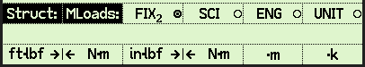
Typical moment-based loads
Includes Moments (N.m, ft.lbf, in.lbf)
PLoads: | Pressure-base load conversions | 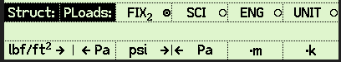
Typical pressure loads
Force/unit area (Pa, lbf/$ft^{2}$, psi)
Mass: | Mass conversions | 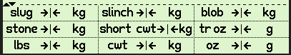
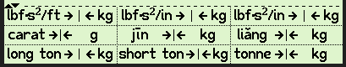
Wide variety of mass conversions.
Includes (kg, lbs, tonnes, tons, short tons, slugs, lbf.$s^{2}$/ft, slinch, blob, lbf.$s^{2}$/in.

General menu structure

Navigate to previous menu
Current menu name
Prefix operators: m – milli – multiply by ${10}^{-3}$ , k – kilo- multiply by ${10}^{3}$. (These are a subset of operators available under the PFX menu [f, EEX] ). These are very helpful for entering larger values.

Number entry examples
With one of the Struct: sub-menus active
Display mode FIX-2 (iℝ set)
To enter 135,000: [130, F6] Display: 135 000
To enter 124,000,000: [124 F6, F6] Display: 124 000 000
To enter 1.24 x ${10}^{-3}$: [1.24 F5] Display: 1.24×⑽⁻³
Display mode UNIT-2 (iℝ set)
To enter 135,000: [130, F6] Display: 135. k
To enter 124,000,000: [124 F6, F6] Display: 124. M
To enter 1.24 x ${10}^{-3}$: [1.24 F5] Display: 1.24 m

Conversion direction arrows
The CONVhp flag is used to control the direction of the arrows in the conversion menus. This provides a great visual clue when performing conversions.
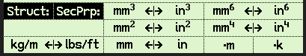
CONVhp cleared:
Usage: I HAVE $in^{3}$ and WANT $mm^{3}$
CONVhp set:
Usage: I WANT $mm^{3}$ and HAVE $in^{3}$

Conversion result unit display
The displays also provide feedback after a conversion is done to give visual verification that the correct conversion has been performed. See below after performing a conversion of $in^{4}$ to $mm^{4}$
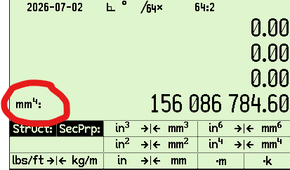

Conversion examples
Conversion example 1:
You need to manufacture a structure that has been designed using steel sections available in the US (imperial dimensions). You want to use alternative sections that are available in your country (metric sections).
US section properties:
W16x31 wide flange beam
Ixx: = 375 $in^{4}$
Sx: = 47.2 $in^{3}$
Yield strength: 36 ksi (A36 grade)
Calculate equivalent metric properties
Action | Keystrokes | Display
Display SecPrp: menu | R47: [f, 2, g, F2, F1]  C47: [f, 5, g, F2, F1] | 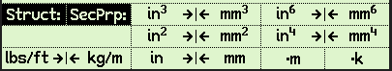
Convert Ixx | [375, f, F5] | 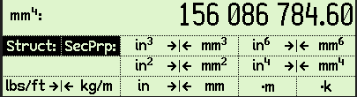
Convert Sx | [47.3, g, F3] | 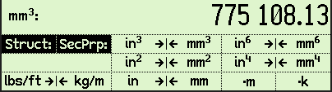
Display MatPrp: menu | [g, F1, F2] | 
Convert yield strength | [36, f, F1] | 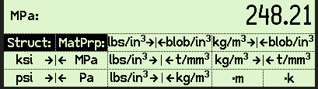

From Table 9 below for Yield strength 300MPa steel, 360UB 56.7 is the smallest beam that provides the necessary properties to replace the US sourced beam.
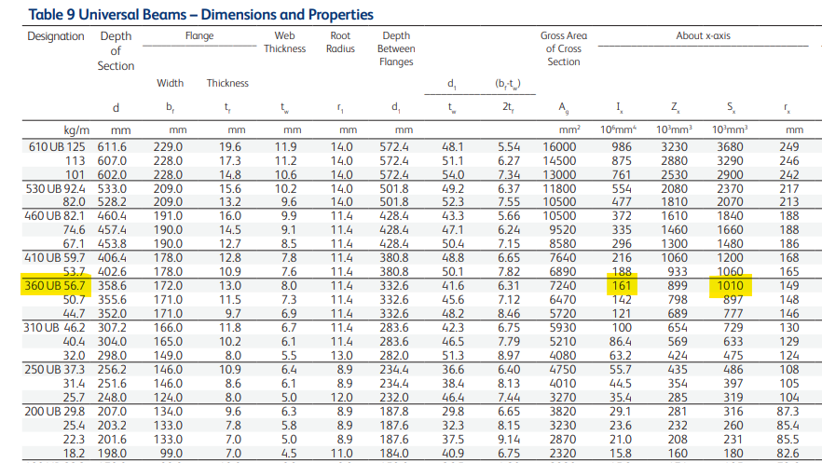

Conversion example 2:
You are performing a FEA analysis on an ALU part. The FEA is using units of inch, lbs. You need to provide several parameters for the FEA configuration using ALU grade 6061-T651:
ALU Properties:
Modulus of elasticity: 68 GPa
Yield strength: 245 MPa
Density: 2700 kg/m^3
Load case:
Gravity load of 3.5g
Calculate equivalent material properties for FEA input

Action | Keystrokes | Display
Display MatPrp: menu | R47: [f, 2, g, F2, F2]  C47: [f, 5, g, F2, F2] | 
Convert Modulus of elasticity to units of psi | [68, EEX, 9 ENTER, F2] | 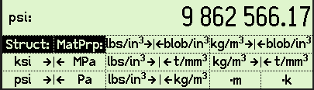
Convert Yield strength to units of ksi | [245, f, F2] | 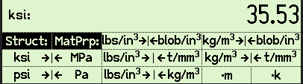
Display FLoads : menu | [g, F1, F3] | 
Convert gravity load to units of in/$s^{2}$ | [3.5, ENTER, 9.8, ×, f, F5] | 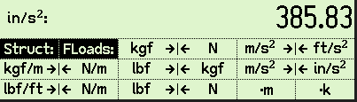

Author David Abram. Proofread Jaco Mostert. Copyright (C) 2026 The R47/C47 Development Team. Permission is granted to copy, distribute and/or modify this document under the terms of the GNU Free Documentation License, Version 1.3 or any later version published by the Free Software Foundation; with no Invariant Sections, no Front-Cover Texts, and no Back-Cover Texts. A copy of the license can be downloaded from gnu.org.

